<https://www.kandyselection.lk/category/45/soulmate>

kandy website

<https://www.thilakawardhana.com/>

thilakawardhana website

<https://www.fashionlanka.com/directory/listing/kandy-selection-kadawatha>

fashin lanka website

<https://www.youtube.com/watch?v=oYRda7UtuhA>

youtube link

<https://www.youtube.com/watch?v=Jq_Zebxa-YI> meka godak hodai

<https://images.app.goo.gl/T6vXfeaXZPDNaR7z8>

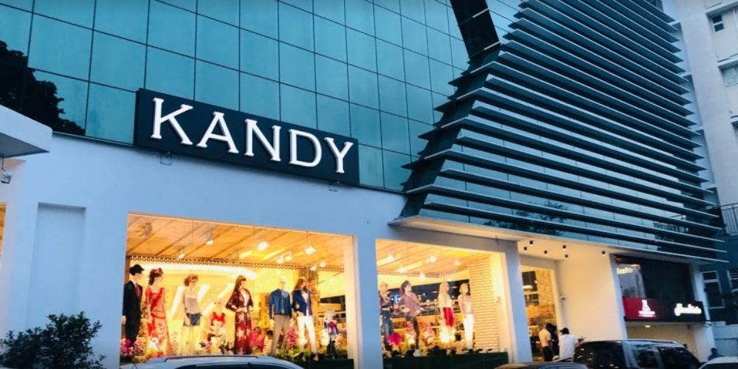

<https://imagekit.io/blog/how-to-resize-image-in-html/#:~:text=If%20your%20image%20doesn't,width%20of%20the%20image%20element>.

Google link

<https://wordpress.com/support/media/image-optimization/> image quality

<https://www.youtube.com/watch?v=oYRda7UtuhA&t=631s>

full u tube video

picture u tube link

<https://www.youtube.com/watch?v=Xnf5eygGdfs>

<https://www.google.com/search?sca_esv=589597305&rlz=1C1CHZN_enLK979LK979&sxsrf=AM9HkKlH-D188C9XzuCVHk3egLRRyqx9Sw:1702230890477&q=html+website+for+online+shopping&tbm=vid&source=lnms&sa=X&ved=2ahUKEwjQv7WcuIWDAxWXSmwGHYJuAisQ0pQJegQISRAB&biw=1536&bih=707&dpr=1.25#fpstate=ive&vld=cid:d1ea2383,vid:hhJxHH5Da_M,st:0>

u tube link for shopping store

<https://www.youtube.com/watch?v=0SktamdLLAQ>

lklhk